ASSIGNMENT – 4

Subject – Computer Science Workshop-1(CSE 2141)

NAME – DEEPTESH ROUT

Registration Number – 2341018166

Section – 23412G1

Branch – B. Tech (CSE)

1.Create a responsive HTML page as described below:Design a card with the header as "2023 Bye Bye", the footer as "Welcome 2024" and the body as "Happy New Year". Add a navigation menu containing values such as "Will go for the movie," "Will go for a tour," "Will go for the feast," "Will go for a long drive," and "Will go for Satsang." Add a vertical navigation menu containing the same values. Add a navigation tab containing the same values. Add a navigation pill containing the same values.
Answer: -

HTML CODE

<!DOCTYPE html>
<html lang="en">
<head>
<meta charset="UTF-8">
<meta name="viewport" content="width=device-width, initial-scale=1.0">
<title>Responsive Card with Navigation</title>
<link href="https://cdn.jsdelivr.net/npm/bootstrap@5.3.3/dist/css/bootstrap.min.css" rel="stylesheet">
<script src="https://ajax.googleapis.com/ajax/libs/jquery/3.3.1/jquery.min.js"></script>
<script src="https://cdnjs.cloudflare.com/ajax/libs/popper.js/1.14.6/umd/popper.min.js"></script>
<script src="https://maxcdn.bootstrapcdn.com/bootstrap/4.1.3/js/bootstrap.min.js"></script>

</head>
<body>
<div class="container py-5">

<div class="text-center mb-4">
<h1>Responsive Card with Navigation</h1>
</div>

<div class="card text-center mb-4">
<div class="card-header bg-primary text-white">
2023 Bye Bye
</div>
<div class="card-body">
<h5 class="card-title">Happy New Year</h5>
</div>
<div class="card-footer bg-success text-white">
Welcome 2024
</div>
</div>

<h4>Horizontal Navigation Menu</h4>
<ul class="nav nav-tabs mb-4">
<li class="nav-item">
<a class="nav-link active" href="#">Will go for the movie</a>
</li>
<li class="nav-item">
<a class="nav-link" href="#">Will go for a tour</a>
</li>
<li class="nav-item">
<a class="nav-link" href="#">Will go for the feast</a>
</li>
<li class="nav-item">
<a class="nav-link" href="#">Will go for a long drive</a>
</li>
<li class="nav-item">
<a class="nav-link" href="#">Will go for Satsang</a>
</li>
</ul>

<h4>Vertical Navigation Menu</h4>
<ul class="nav flex-column mb-4">
<li class="nav-item">
<a class="nav-link" href="#">Will go for the movie</a>
</li>
<li class="nav-item">
<a class="nav-link" href="#">Will go for a tour</a>
</li>
<li class="nav-item">
<a class="nav-link" href="#">Will go for the feast</a>
</li>
<li class="nav-item">
<a class="nav-link" href="#">Will go for a long drive</a>
</li>
<li class="nav-item">
<a class="nav-link" href="#">Will go for Satsang</a>
</li>
</ul>

<h4>Navigation Pills</h4>
<ul class="nav nav-pills">
<li class="nav-item">
<a class="nav-link active" href="#">Will go for the movie</a>
</li>
<li class="nav-item">
<a class="nav-link" href="#">Will go for a tour</a>
</li>
<li class="nav-item">
<a class="nav-link" href="#">Will go for the feast</a>
</li>
<li class="nav-item">
<a class="nav-link" href="#">Will go for a long drive</a>
</li>
<li class="nav-item">
<a class="nav-link" href="#">Will go for Satsang</a>
</li>
</ul>
</div>
</body>
</html>

OUTPUT OF THE CODE: -
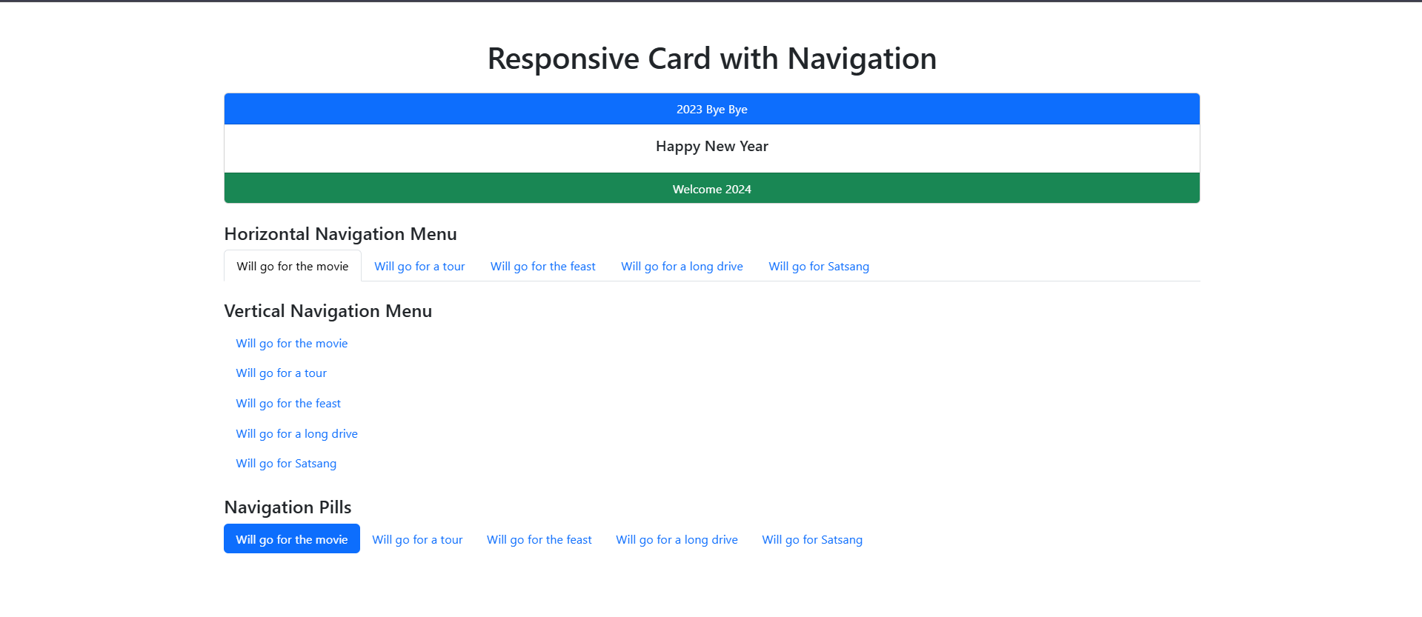

Create a responsive HTML page as described below: . Add a menu with three options CSE, CSIT, and CA. CSE has 5 options as CSE-Core, CSE-DS, CSE-AIML, CSE- CYS, and CSE-IoT, whereas, CA has 2 options as MCA and BCA in the drop-down list to the menu. Add the color-animated progress bars with stripes showing the admission percentage to these courses. (Remember, it should be varied from 90 to 100 %) Add a pagination of 5 in medium size to this HTML page. (Remember 3 is to be in Active state)

ANSWER

HTML CODE

<!DOCTYPE html>
<html lang="en">
<head>
<meta charset="UTF-8">
<meta name="viewport" content="width=device-width, initial-scale=1.0">
<title>Responsive Page</title>

<link href="https://cdn.jsdelivr.net/npm/bootstrap@5.3.2/dist/css/bootstrap.min.css" rel="stylesheet">
</head>
<body>

<nav class="navbar navbar-expand-lg navbar-light bg-light">
<div class="container-fluid">
<a class="navbar-brand" href="#">Courses</a>
<button class="navbar-toggler" type="button" data-bs-toggle="collapse" data-bs-target="#navbarNav">
<span class="navbar-toggler-icon"></span>
</button>
<div class="collapse navbar-collapse" id="navbarNav">
<ul class="navbar-nav">
<li class="nav-item dropdown">
<a class="nav-link dropdown-toggle" href="#" id="cseMenu" role="button" data-bs-toggle="dropdown">
CSE
</a>
<ul class="dropdown-menu" aria-labelledby="cseMenu">
<li><a class="dropdown-item" href="#">CSE-Core</a></li>
<li><a class="dropdown-item" href="#">CSE-DS</a></li>
<li><a class="dropdown-item" href="#">CSE-AIML</a></li>
<li><a class="dropdown-item" href="#">CSE-CYS</a></li>
<li><a class="dropdown-item" href="#">CSE-IoT</a></li>
</ul>
</li>
<li class="nav-item dropdown">
<a class="nav-link dropdown-toggle" href="#" id="csitMenu" role="button" data-bs-toggle="dropdown">
CSIT
</a>
<ul class="dropdown-menu" aria-labelledby="csitMenu">
<li><a class="dropdown-item" href="#">CSIT-Option1</a></li>
<li><a class="dropdown-item" href="#">CSIT-Option2</a></li>
</ul>
</li>
<li class="nav-item dropdown">
<a class="nav-link dropdown-toggle" href="#" id="caMenu" role="button" data-bs-toggle="dropdown">
CA
</a>
<ul class="dropdown-menu" aria-labelledby="caMenu">
<li><a class="dropdown-item" href="#">MCA</a></li>
<li><a class="dropdown-item" href="#">BCA</a></li>
</ul>
</li>
</ul>
</div>
</div>
</nav>

<!-- Progress Bars Section -->
<div class="container mt-5">
<h2 class="mb-4">Admission Percentages</h2>
<div class="mb-3">
<label>CSE-Core</label>
<div class="progress">
<div class="progress-bar progress-bar-striped bg-success" style="width: 95%;">95%</div>
</div>
</div>
<div class="mb-3">
<label>CSE-AIML</label>
<div class="progress">
<div class="progress-bar progress-bar-striped bg-primary" style="width: 98%;">98%</div>
</div>
</div>
<div class="mb-3">
<label>BCA</label>
<div class="progress">
<div class="progress-bar progress-bar-striped bg-warning" style="width: 92%;">92%</div>
</div>
</div>
<div class="mb-3">
<label>MCA</label>
<div class="progress">
<div class="progress-bar progress-bar-striped bg-danger" style="width: 90%;">90%</div>
</div>
</div>
</div>

<!-- Pagination Section -->
<div class="container mt-5">
<nav aria-label="Page navigation">
<ul class="pagination justify-content-center">
<li class="page-item"><a class="page-link" href="#">1</a></li>
<li class="page-item"><a class="page-link" href="#">2</a></li>
<li class="page-item active"><a class="page-link" href="#">3</a></li>
<li class="page-item"><a class="page-link" href="#">4</a></li>
<li class="page-item"><a class="page-link" href="#">5</a></li>
</ul>
</nav>
</div>

<!-- Bootstrap JS Bundle -->
<script src="https://cdn.jsdelivr.net/npm/bootstrap@5.3.2/dist/js/bootstrap.bundle.min.js"></script>
</body>
</html>

OUTPUT OF THE CODE
